REGULAR MEETING MINUTES
November 28th 8:15 PM
NOTICE IS HEREBY GIVEN​ that the General Studies Student Council of Columbia University will hold a REGULAR meeting on November 28th 8:15 PM. The meeting information is noted below. The General Studies Student Council reserves the right to suspend the orders of the day if necessary to conduct business. All General Studies Student Council meetings are held in locations that are wheelchair accessible. Other disability-related accommodations will be provided to persons with disabilities upon request. Persons requesting such accommodations should notify the General Studies Student Council President no less than three (3) working days prior to the meeting. The General Studies Student Council will make efforts to meet requests made after such date, if possible. Please also contact the General Studies Student Council Executive Board for any agenda-related questions.
- Order of Business
  - Call to order
  - Roll Call
Officer | Status |  | Officer | Status
President Nasser Odetallah | P |  | Treasurer Michael Galvin | P
VP of Policy Savanah Shulkin | P |  | *Finance Coordinator Rychard Tymakhovych | P
VP of Finance Simas Chacar-Palubinskas | E |  | Social Media Rep. Isabel Tenney | P
VP of Communications Oliver Neale | P |  | Technology Chair Jacob Resnick | P
VP of Campus Life Kat Zimmermann | P |  | *Content Coordinator Evan Edler | P
Chief of Policy Jonathan DuCloud | P |  | *Communications Coordinator Caroline Nicholson | P
Chief of Finance Eric Yu | P |  | *Communications Coordinator Anatta Tantiwongse | P
Chief of Communications Melanie Wells | P |  | Alumni Affairs Rep. Clara Kruijtzer | P
Chief of Campus Life Olivia McAlpine | P |  | International Students Rep. Aoife Houlihan | P
Student Services & Academic Affairs Rep. Oscar Wolfe | P |  | Jewish Theological Seminary (JTS) Rep. Ilan Cohen | P
First-Generation, Low-Income, and Working Students Representative Freida Candido | P |  | Community Service and Sustainability Rep. Jemima Kingdon Jones | P
Veteran Students Rep. Brian Williams | P |  | Senior Class President Faith Grady | P
Students with Disabilities Rep. Alec Rodriguez Stangle | E |  | Senior Class Vice President Nick Feibel | P
Diversity & Equity Rep. Madison Cabellos-Rivera | P |  | First Year Class President Lily Canter | P
Health & Wellness Rep. Malika Ali | P |  | First Year Class Vice President Ayşe Lara Selçuker | P
*Commuting Students & Students with Families Rep. Walter Koike-Sieira | P |  | Dual BA & Joint Program Rep. Taylor Moniz | P
*Policy Coordinator Alina Kreynovich | P |  | *Campus Life Coordinator Haya Fine | P
*Policy Coordinator Chelsey Giraldo | P |  | University Senator Bruce Goumain | P
*Policy Coordinator Marquise Johnson | P |  | Voting Members: 27 → Quorum → 20 Total: | 25

  - Adoption of the Current Agenda for November 28th 2023
    - Motion Passes/Fails- PASSES
  - Adoption of the Meeting Minutes from November 21st, 2023
    - Motion Passes/Fails- PASSES

REPORTS
  - President
    - General Updates
      - Registration reopens on monday
      - Course search project - registration and waitlist for next year
        - Savanna, Jonathan, Bruce, and Nassar have been presenting to all undergraduate council
        - All approved
        - Will be presented to faculty and senate
  - Policy
    - No updates
  - Finance
    - No updates
  - Communications
    - Takeovers!
      - IG Takeovers started today, thank you Savannah! *round of applause* XOXO
      - There is now a sign-up sheet for takeovers, everyone’s invited!
  - Campus Life
    - Tree Lighting Reminder
      - Hello from Kat :)
      - This Thursday
      - If you volunteered: please wear merch items so people know who you are and what group you represent
      - Remember what time and what you signed up for if you volunteered !
      - Line up at 5→ Groups perform at 6:30/ lights go on after performance
    - Plant n’ Paint Reminder
      - December 9th
      - If you want to help out that would be great
      - Form going out in slack for Gala Theme Ideas hehehe

- NEW BUSINESS
  - Finals Snack Attacks
    - 8 days of Snack Attacks!
    - We’re going back to all hot meals and back to 4 days
    - Currently looking at $2,000
      - We have $1,xxx left from midterms and alumni affairs has also offered to chip in $500
      - Need to cover $6, xxx
      - Motion to allocate 7.5k from the snack attack line item
      - Motion PASSES
  - Spring Orientation Votes
    - GSSC hosts a welcome event & info session for both fall & spring orientation
      - Fall: Mel’s event
      - Have little money left over for Spring orientation
    - 5 pizzas, 4 2-liter bottles, 2 large assorted packs of candy: for information session
      - Unsure if want to do welcome event
    - Total: $201.04 - but in orientation budget: only $121.43 left -> take $100 from student event budget line item: total of $222
    - Pizza likely from Famiglia
  - Coffee Circle Social Presentation
    - friday january 26th at 2pm in the GS lounge
    - social event to bring people with same professional interests together to connect (no matter level of interest)
    - will have circles for a number of professional themes (finance, consulting, biomed, tech, media, etc.) and a circle for everything else
    - plan to have a paper for each circle with questions to discuss and a signup sheet with contact information
      - sample questions include class/professor advice, internship experience, etc.
    - need some donuts, cookies, muffins, amd more from JJs, plus amazon name tags - total of $80 from the student event line item
  - By-Laws Amendments
    - First time we have had to do this
      - Amendments are the same as the normal vote, we need ⅗ majority instead of simple majority
    - Motion for 5 minutes of discussion max for each amendment
      - Passed unanimously
    - Article 6: elections, all amendments will be here
      - Subcommittee on elections (SE)
      - Elections Task Force (ETF), non-council members
    - Amendment 1, SE
      - SE used to have undefined people
        - 7 members now
      - How to pick members of SE
        - For SE Chair
          - supposed to be graduating seniors in may
          - Now there is a ranked order, graduating senior first,
          - See ranking:
          - 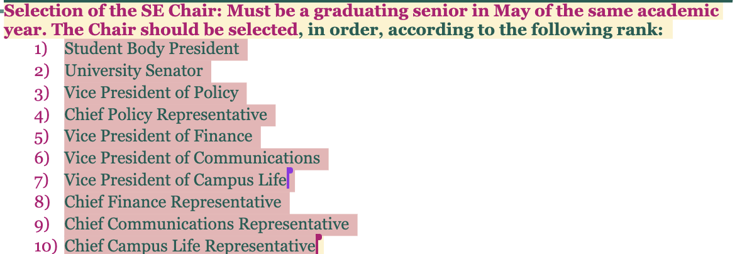
        - For other SE members:
          - Copy/paste:
          - Selection of Remaining SE Members: After selecting the Chair, the SE will be filled with six (6) more members, according to the principles below:
          - The SE, when possible, should have a representative graduating senior from each of the four Committees on GSSC. If there is only one graduating senior on a Committee, that Member automatically joins the SE. If there are more than one senior in a Committee, a random selection shall occur from each Committee, to be carried out by the Executive Board. If there are no graduating seniors on a GSSC Committee, that Committee shall not have any members on the SE.
          - After filling the SE with a graduating senior from each Committee, a random selection of all remaining graduating seniors on GSSC shall be carried by the Executive Board to bring the total number of members on the SE to seven (7), including the Chair.
          - Any Council Member who is selected to join the SE may turn down the selection by notifying the Executive Board ahead of the first meeting of the SE.
          - If there are not a total of seven (7) graduating seniors on GSSC in a given year, a simple interest form will be sent out to the GS student body through the GSSC newsletter to solicit volunteers to join the SE. Interested students will present themselves at a General Body Meeting to join the SE through a simple majority council vote. These students will be ineligible to join the Elections Task Force (ETF).
          - The final roster of the SE shall be publicly announced by the GSSC Student Body President or another Executive Board Member during a GSSC General Body Meeting.
        - Question on ensuring the integrity of the committee members for the rationale of Chair Ranking
          - Whoever is running the subcommittee must be familiar with the bylaws
      - Motion passes 24:2
    - Amendment 2: elections task force, ETF, non-council members
      - People who actually run the election and violations and appeals
      - Unbiased!!
        - Cannot be on the council following year
      - CHANGES:
        - Expanding etf from 3 to 5 members
          - No rush decisions
        - Specified 5 people, everyone has specific roles
          - From 1 chair to 2 co-chairs
          - Event planner (already existed)
          - Communications manager (already existed)
          - Secretary (new role)
            - Reads bylaws aloud to all candidates and documents everything
        - Specified process by which resignation occurs in ETF
          - GSSC oversees SE, SE oversees ETF
            - SE finds members for ETF, GSSC votes on ETF members
        - Question:
          - Flex minimum of 3 etf members, preferred 5
        - First thing SE does is appoint 2 co-chairs
          - While ETF fills, SE helps ETF out
        - Timeline of election period?
          - Typo crossed out
            - Way etf gets removed or resigns, SE evaluates it
          - Election period used to be defined by when ETF starts, now it is earlier
      - Ammendment passes unanimously
    - Amendment 3: elections packet
        - Rephrasal
        - Now the ETF secretary is responsible for creating elections packet
          - New role, new duty
        - Election packet is sent out to candidates when they say they want to run
          - Basically how they act as a candidate
            - To get endorsement, approvals, etc.
      - Motion Passes Unanimously
    - Amendment 4: timeline adjusted
      - 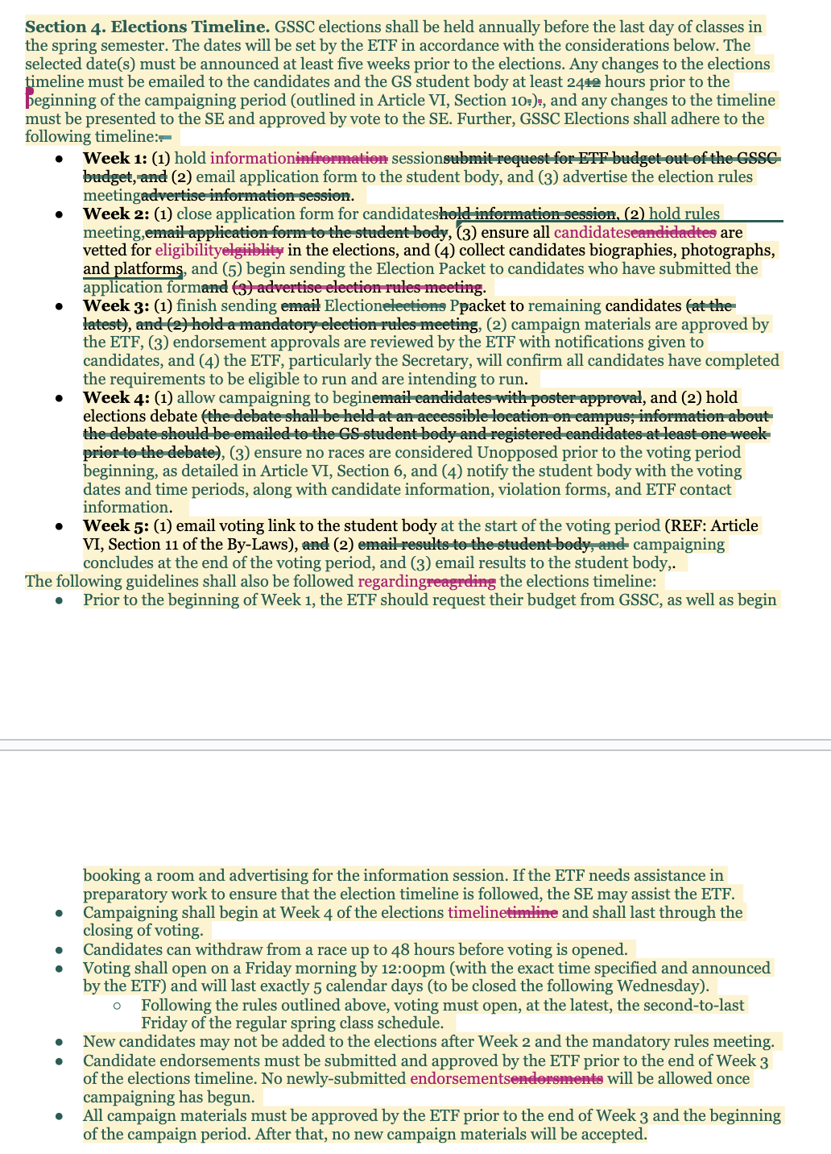
        - 5-week structure
          - See photo for changes
        - Specified when endorsements are due
        - Campaigning is now allowed throughout the entire election cycle
        - When does voting begin (Friday morning, by noon)
          - Ends 5 calendar days later (Wednesday by noon)
        - Allows for more engagement, people do not work on weekends mostly
        - Allows results out by Friday
        - Withdrawal is only allowed up until 48 hours before voting
        - More specification for ease of election
      - Most changes are just specifying what is there
      - Maybe people not allowed to campaign at student events?
        - In the campaigning section, which will be covered later
      - Motion passes unanimously
    - Amendment 5 - university senator role
      - Rephrasals
        - Made more clear
        - Term is 2 years, if there is no senator there is an election
      - Possibly advocate for GS to have 2 senators
        - Rules reflect election in the case that we get more than one senator
      - Why do we only have 1 senator?
        - Only the undergraduate school with the most students gets 2 senators or more
        - Only cc has that
        - In 3 years we can re-evaluate
      - No real changes, just rephrased if we get 2 senators
      - Motion passes unanimously
    - Amendment 6 - eligibility
      - Actual eligibility not changed
      - Added: unopposed races - confusion on what that entailed
        - Unopposed races are not allowed -> this becomes an appointed position
          - Example: Oliver, Brian
          - Exception: University Senator & President
        - Candidates can withdraw up to 48 hours before voting
          - After 48 hours: cannot - want to avoid scenario of malicious withdrawals
          - If get elected, can just resign the next day, so this is a non-issue
        - Candidates can be removed during voting period due to disqualification
          - Disqualified to race of 2 people -> that race moves forward
            - Exception: Senator & President
              - These cannot be unopposed ever even due to disqualification -> special election (re-election)
              - If disqualified, then cannot run again in special election
        - Candidacy requirements: have to submit name, photo, some barebones platform, show up to debates
          - ETF can ask for these things if not put in on time
          - If after excessive outreach, don’t show up to debate, or don’t show up to rules meeting -> you are disqualified & are not running
          - Rules meeting: if tell ETF in advance, can have makeup
          - Debates: need to be there; no makeup - but for extreme extenuating circumstances, ETF may waive this requirement
      - Motion passes
    - Amendment 7 - Threshold races
      - Student Body President & University Senator must have at least 100 votes in order to win
      - E-board, Senior Pres & VP: 75 votes
      - Non-eboard elected positions: 50 votes
      - Note: these thresholds have never not been met before
      - To encourage active campaigning
      - Motion passes
    - Amendment 8 - Campaigning & endorsements
      - Campaigning:
        - Campaigning can happen through voting
        - No campaigning at large events
        - Social media counts as campaigning
        - “Conscious intention” counts as campaigning (future AI, etc)
        - Candidate conduct
          - Got rid of section saying that candidates are responsible for conduct of other students & organizations
          - The intention behind this rule was good but the standard & wording is too strong: people cannot control other people
          - Added: candidates are responsible for their conduct during election timeline
          - Added: candidates have to adhere to a strong ethical standard
      - Endorsements:
        - Candidates can present platform to E-Boards before endorsement form goes out
        - Can start meeting with groups early on but endorsement form must be submitted by week 3
        - Cannot be endorsed by IGB & Senate
      - Motion passes
    - Amendment 9 - Voting
      - Specified time for voting
      - If technological tampering with the ballot - the ETF will consult w administration to investigate
      - Got rid of paragraph about election information
      - Tallied votes: thresholds for other roles
      - Special elections
        - Wrote out already existing rules in more details
        - Races for Senator & SBP - if no one reaches 100 votes -> special election
          - If race of 2 candidates & no one reaches 100 votes -> special election: both candidates automatically in (there is opportunity for other candidates to join)
          - If race of 2 candidates & someone disqualified -> disqualified people cannot move onto special election
        - Motion passes
    - Amendment 10 - adjudication
      - When complaint initially sent in, the ETF has 12 hours to decide to investigate
      - Removal of the strike system
        - Strike system: found guilty of violation -> strike 1. 2 strikes -> disqualified
        - Removed because someone doing something extremely severe can get away with it, someone doing a bunch of things but at the same time can get away with it because it may be considered only one strike, can be used to get people in trouble with very little/silly things
      - Replaced with contextual-based punishment system
        - Same timeline, same process of investigation
        - Suggested punishments added
          - Small infraction: warning
            - Chance to meet with ETF: tell what to fix, how to fix
          - Medium infraction: sanction
            - Did something serious that cannot be rectified -> now opponent at disadvantage
            - ETF will issue sanction of 25% vote deduction
            - Sanctions should also be handed out if get multiple warnings
            - Required to meet with ETF
          - Big infraction: disqualification
            - For very serious things that cannot be fixed, severely tampered with elections
            - Sanctions multiple times -> disqualified
            - Violated multiple rules at the same time -> disqualified
            - Repeatedly breaking rules that originally issued warnings -> disqualified
          - Multiple infractions
            - Repeatedly breaking the same rule to the point where disobeying
            - ETF can punish
          - Third-party violations
            - If Third-party entity (individual, recognized student group, unrecognized student group) is committing serious unethical breaches which negatively affects an innocent candidate or gives a candidate an undue advantage -> ETF can punish
          - Election integrity
            - Questions - can ask ETF co-chairs
      - Motion passes
    - Amendment 11 - special elections
      - If first special election results in no candidate receiving 100 votes, a second special election will be held
      - Special elections outside of elections seasons: council assembles ad hoc ETF
      - Candidates who were disqualified in a race in the general GSSC elections due to rules violations may not run in any special election for that academic cycle
      - Motion passes

STANDING BUSINESS
None

COMMUNICATIONS FROM THE FLOOR
This time is reserved for any General Studies Student Council Members to make announcements on items not on the agenda. A time limit of three (3) minutes per speaker and (25) twenty-five minutes total shall be observed. NO action will be taken and the total time limit for this item shall not be extended.

PUBLIC COMMENT
This segment of the meeting is reserved for all non-Council members desiring to address the General Studies Student Council on any matter of concern, A time limit of three (3) minutes per speaker and ten (10) minutes per topic shall be observed. The law does not permit any action to be taken, nor extended discussion of any items not on the agenda. The General Studies Student Council may briefly respond to statements made or questions posed. (Brown Act §54954.3)

EXECUTIVE SESSION
This closed session is reserved for any General Studies Student Council Members to discuss and possibly take action on voting in the nominees for various, posted, council vacancies. The public, and the nominees, will be asked to step out of the room while the council conducts this business.

ADJOURNMENT

