REGULAR MEETING MINUTES
February 27th, 8:15 PM
NOTICE IS HEREBY GIVEN​ that the General Studies Student Council of Columbia University will hold a REGULAR meeting on February 27th 8:15 PM. The meeting information is noted below. The General Studies Student Council reserves the right to suspend the orders of the day if necessary to conduct business. All General Studies Student Council meetings are held in locations that are wheelchair accessible. Other disability-related accommodations will be provided to persons with disabilities upon request. Persons requesting such accommodations should notify the General Studies Student Council President no less than three (3) working days prior to the meeting. The General Studies Student Council will make efforts to meet requests made after such date, if possible. Please also contact the General Studies Student Council Executive Board for any agenda-related questions.
- Order of Business
  - Call to order
  - Roll Call
Officer | Status |  | Officer | Status
President Nasser Odetallah | P |  | Treasurer Michael Galvin | P
VP of Policy Savanah Shulkin | P |  | *Finance Coordinator Rychard Tymakhovych | P
VP of Finance Simas Chacar-Palubinskas | P |  | Social Media Rep. Isabel Tenney | P
VP of Communications Oliver Neale | P |  | Technology Chair Jacob Resnick | P
VP of Campus Life Kat Zimmermann | P |  | *Content Coordinator Evan Edler | P
Chief of Policy Jonathan DuCloud | P |  | *Communications Coordinator Caroline Nicholson | P
Chief of Finance Eric Yu | P |  | Alumni Affairs Rep. Clara Kruijtzer | P
Chief of Communications Melanie Wells | E |  | International Students Rep. Aoife Houlihan | Z
Chief of Campus Life Olivia McAlpine | P |  | Jewish Theological Seminary (JTS) Rep. Ilan Cohen | E
Student Services & Academic Affairs Rep. Oscar Wolfe | P |  | Community Service and Sustainability Rep. Jemima Kingdon Jones | P
First-Generation, Low-Income, and Working Students Representative Chelsey Giraldo | P |  | Senior Class President Faith Grady | P
Veteran Students Rep. Brian Williams | P |  | Senior Class Vice President Nick Feibel | U
Students with Disabilities Rep. Alec Rodriguez Stangle | P |  | First Year Class President Lily Canter | P
Diversity & Equity Rep. Madison Cabellos-Rivera | P |  | First Year Class Vice President Ayşe Lara Selçuker | P
Health & Wellness Rep. Malika Ali | P |  | Dual BA & Joint Program Rep. Taylor Moniz | P
*Commuting Students & Students with Families Rep. Walter Koike-Sieira | P |  | *Campus Life Coordinator Haya Fine | E
*Policy Coordinator Alina Kreynovich | E |  | University Senator Bruce Goumain | E
*Policy Coordinator Marquise Johnson | Z
*Policy Coordinator May Tun | P |  | Voting Members: 27 → Quorum → 20 Total: | _23__

  - Adoption of the Current Agenda for February 27th, 2024
    - Motion Passes/Fails- passes unanimously
  - Adoption of the Meeting Minutes from February 20th, 2024
    - Motion Passes/Fails- passes unanimously

TOWN HALL WITH DEANS
  - Survey - Dean Rosen Metsch
    - Survey topics
      - general info, financing, housing/food insecurity, wellbeing, etc.
    - Survey methodology
      - Cross-sectional survey
      - Through email, social media, website, GS student success survey, Student Survey Ambassadors
      - The purpose is to address the consequences of financial aid not being as supportive as wanted.
        - Mainly on how financial distress affects students' academic success
      - Confidential
      - Flex Dollars as an incentive
    - Objectives
      - Based on students with low income
      - First in family
      - Differences in programs (Dual Degree, etc)
      - How financial distress affects people with disabilities
    - Completion rates
      - 67% response rate Spring 2023 (compared to 56% Spring 2018)
      - 1710 completed / 2559 total students
      - Highly representative by:
        - Veteran, underrepresented, men, women, pell recipient, low income, first gen, first gen or low income, first gen and low income, neither FLI
        - Age, GPA, cumulative credits
    - See slideshow - zoom recording
    - 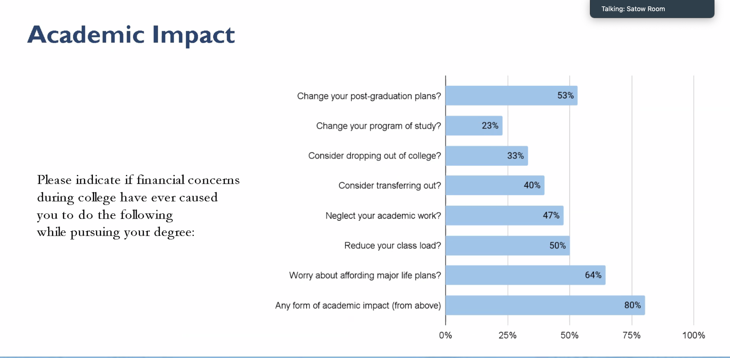
    - 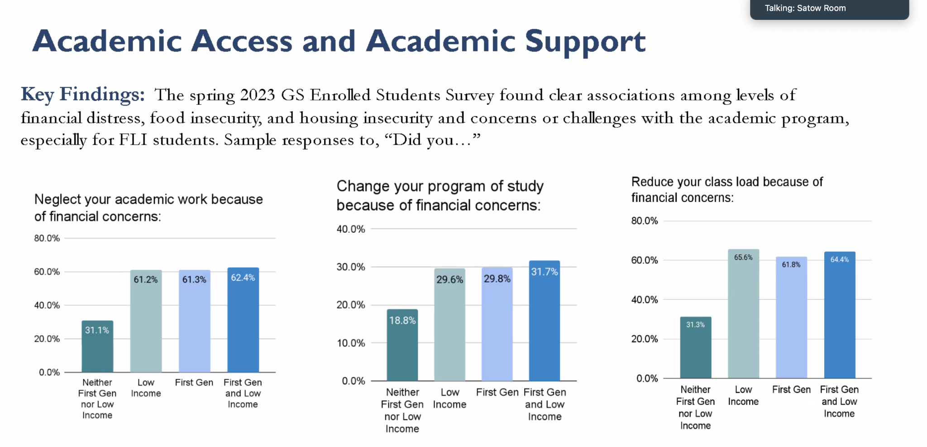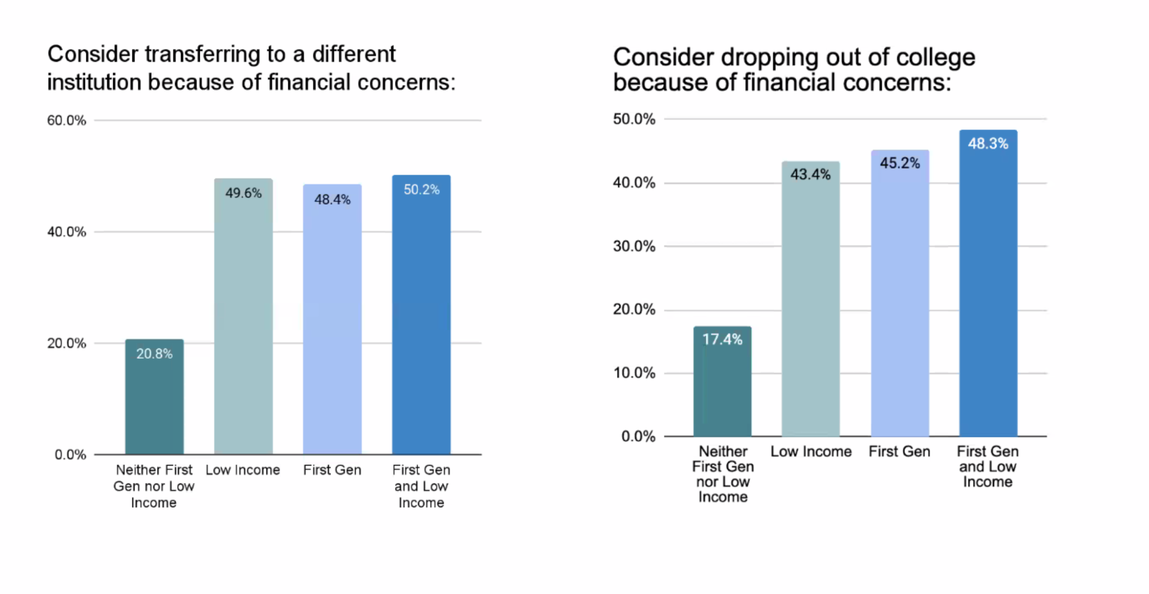
    - 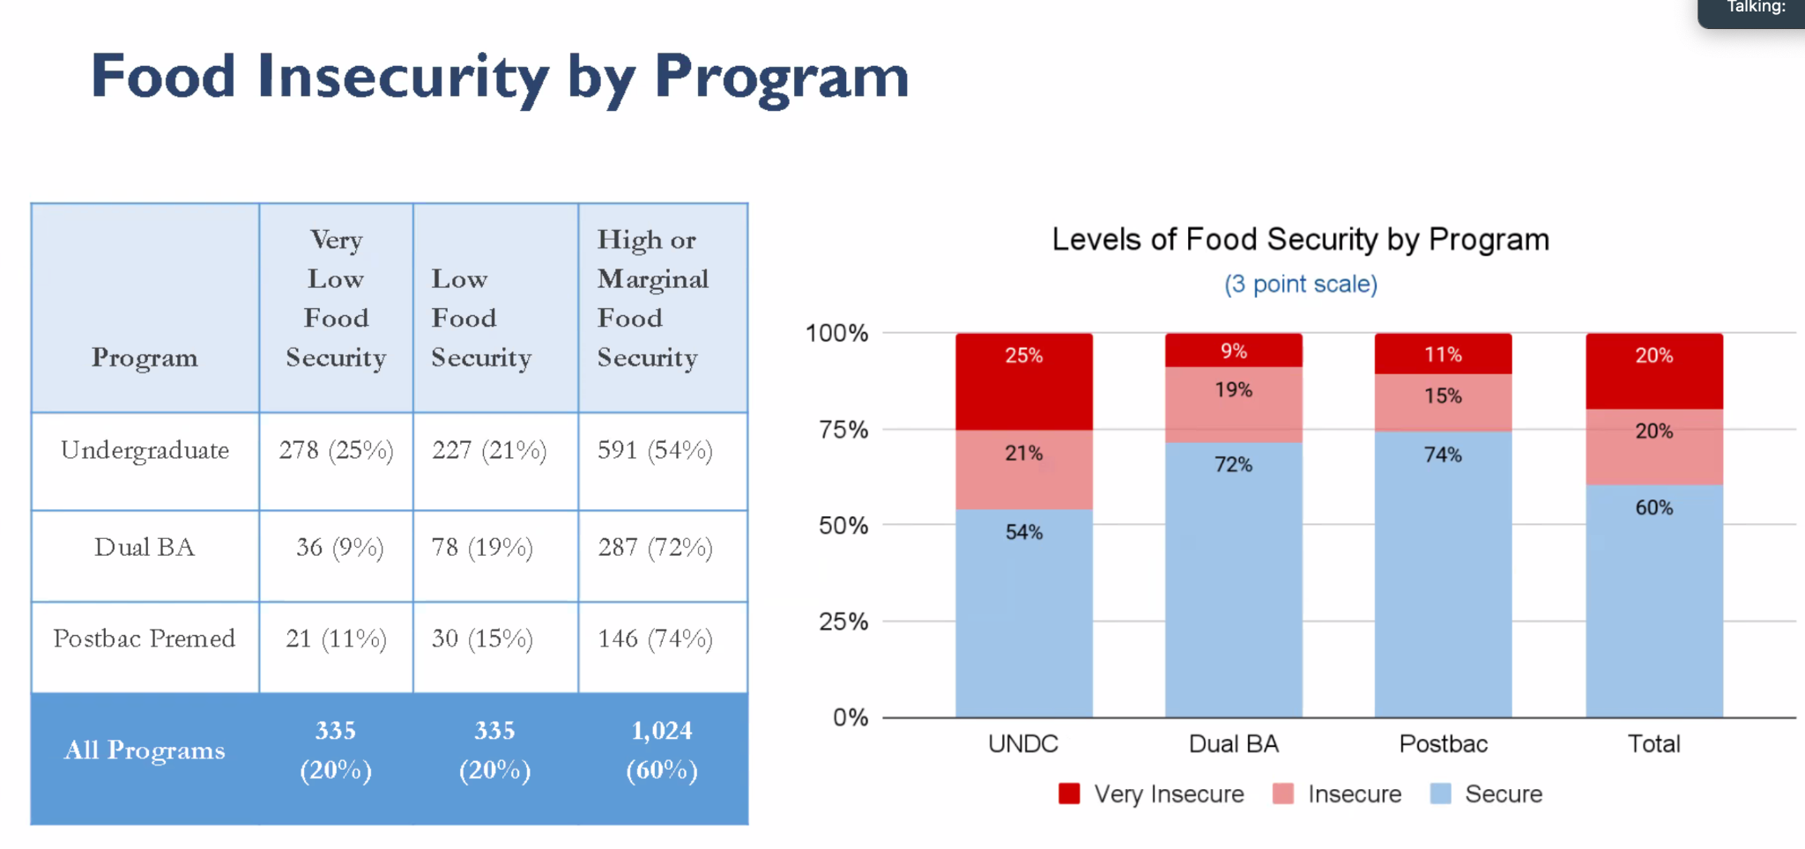
    - 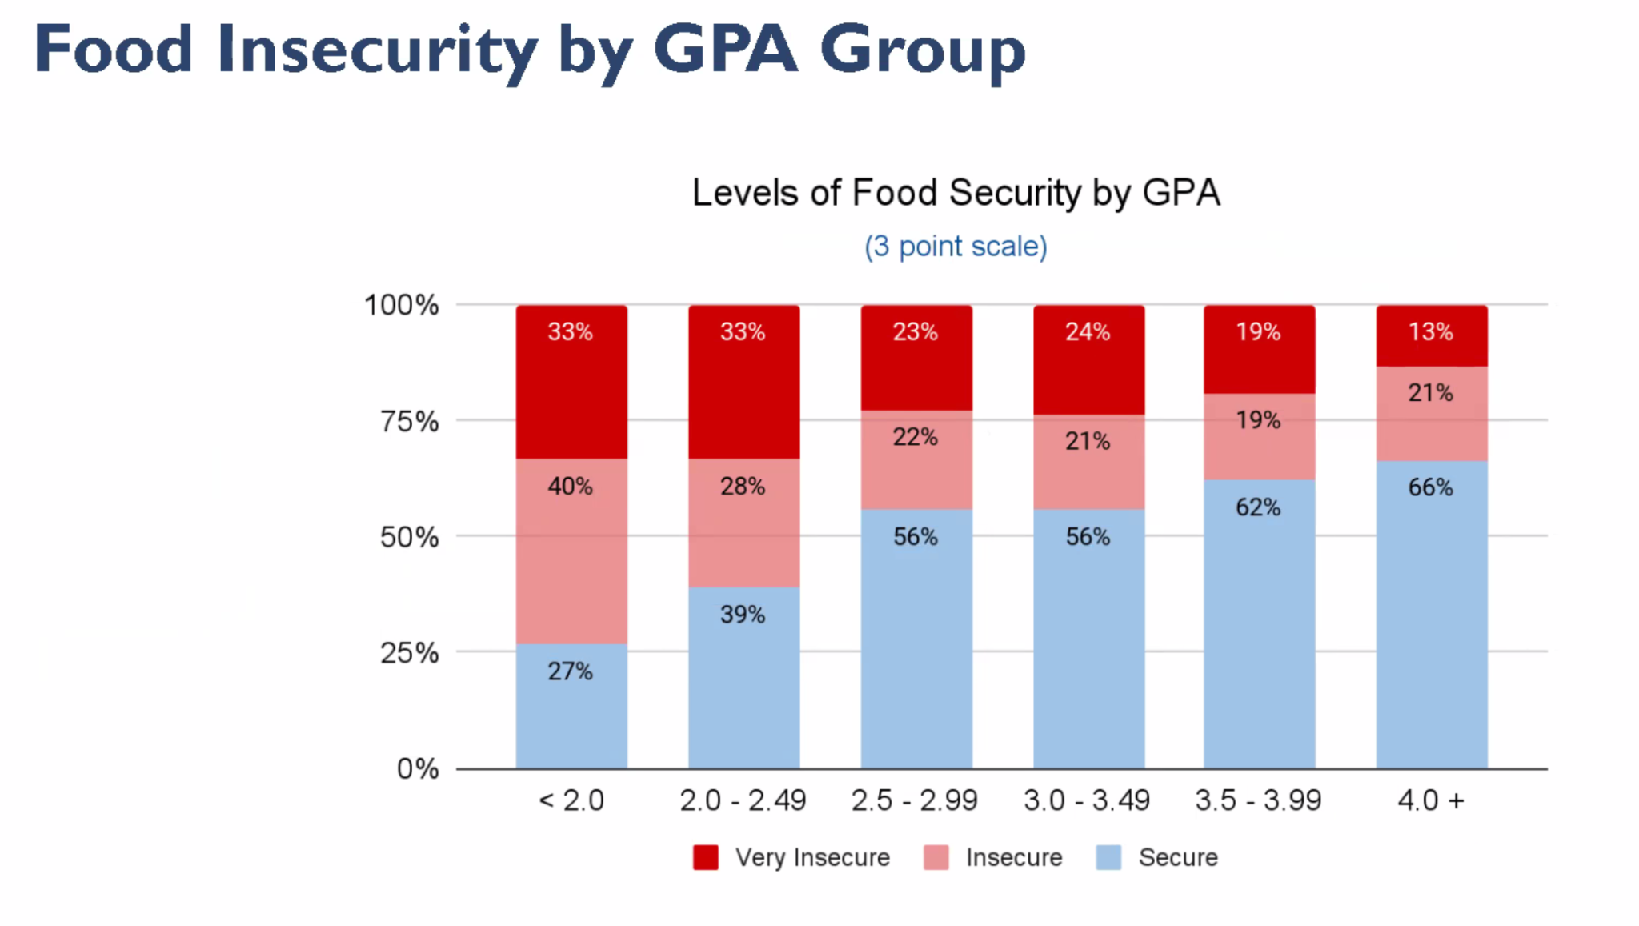
    - 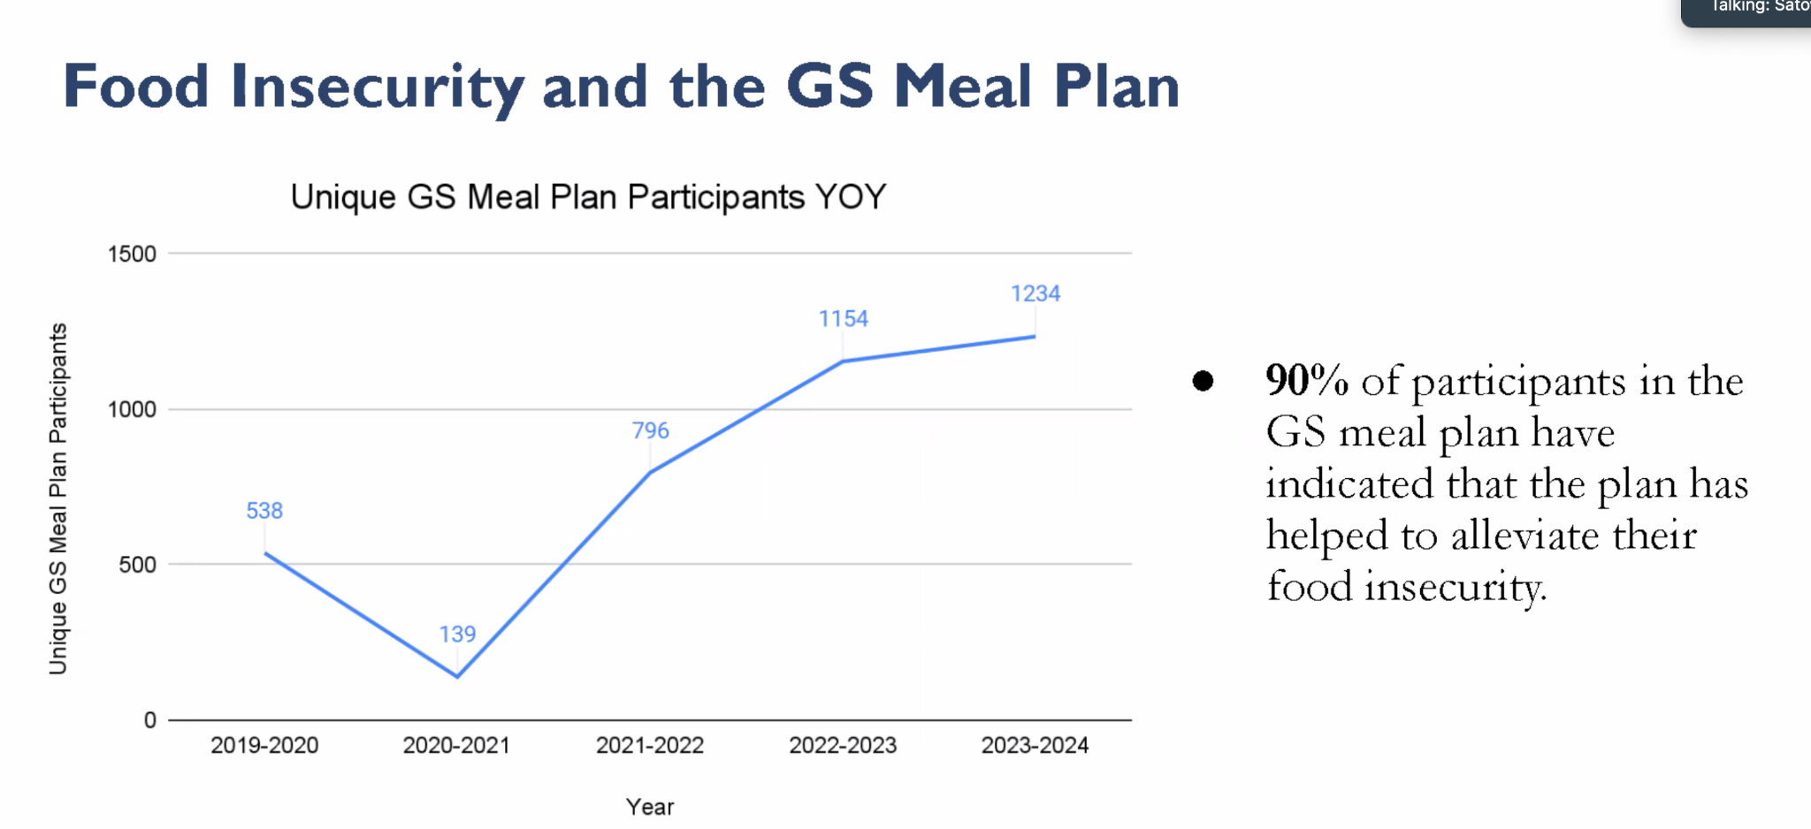
    - 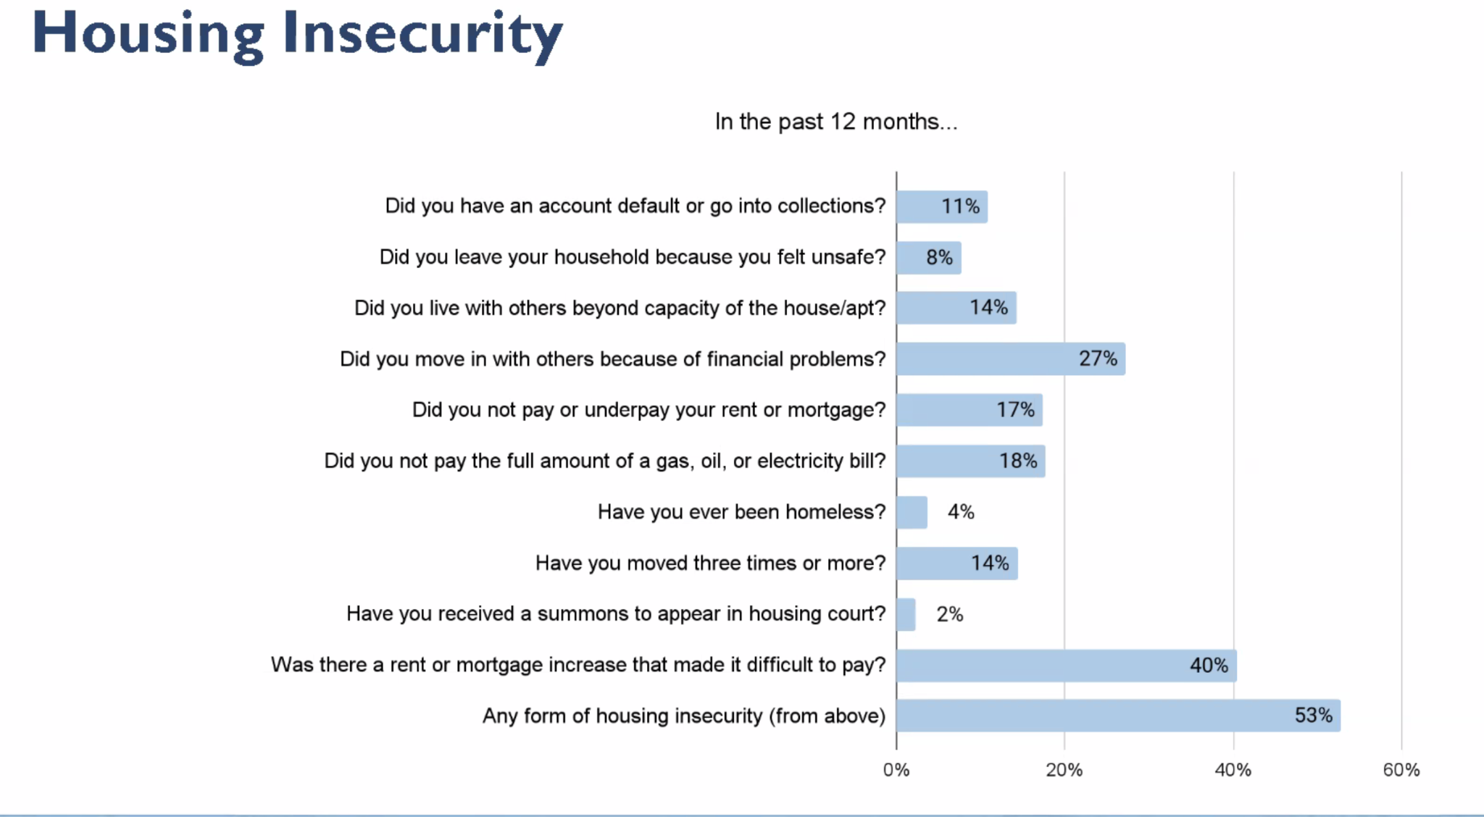
    - 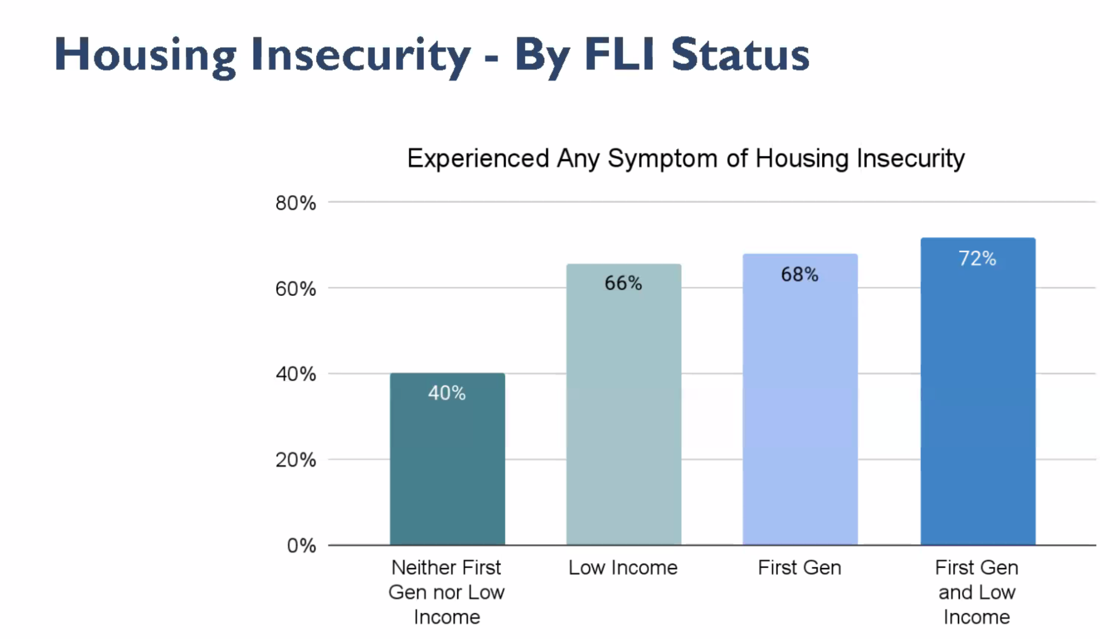
    - 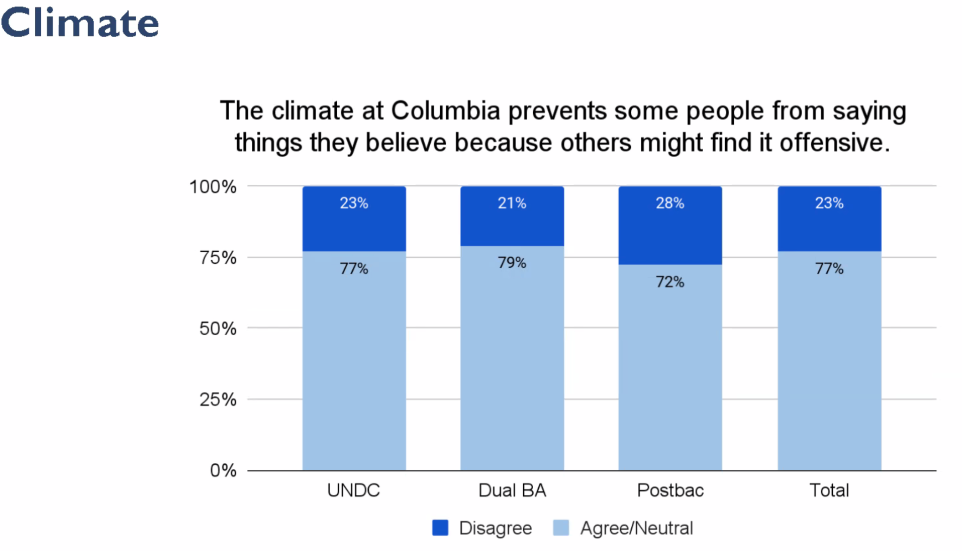
    - 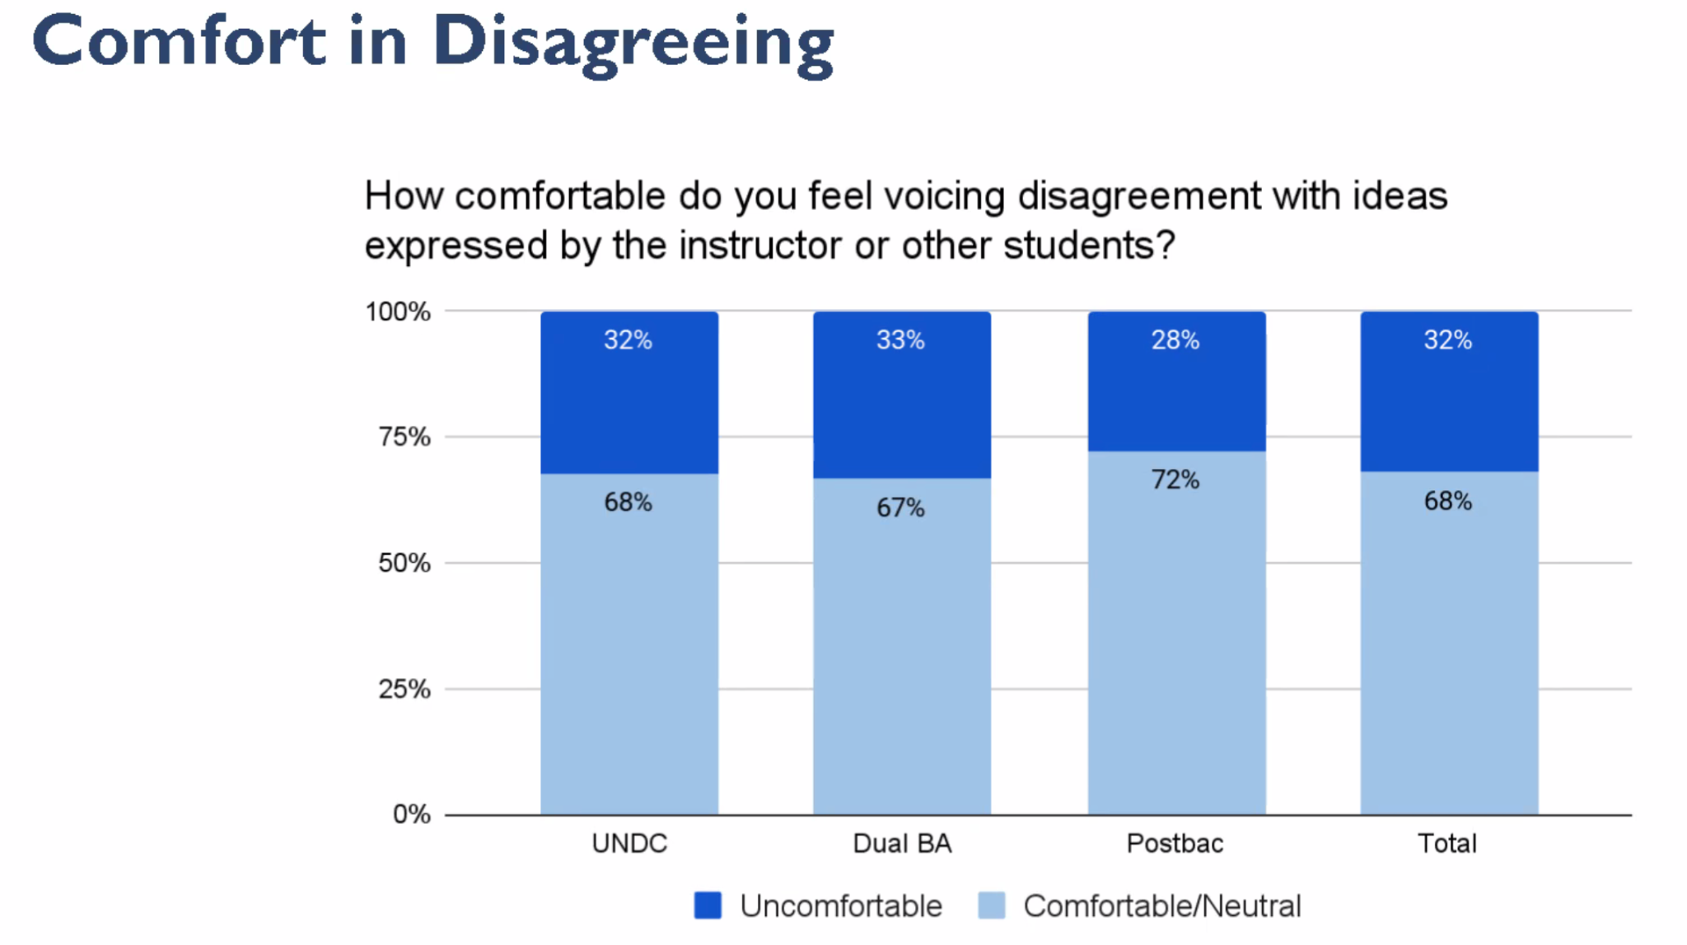
    - 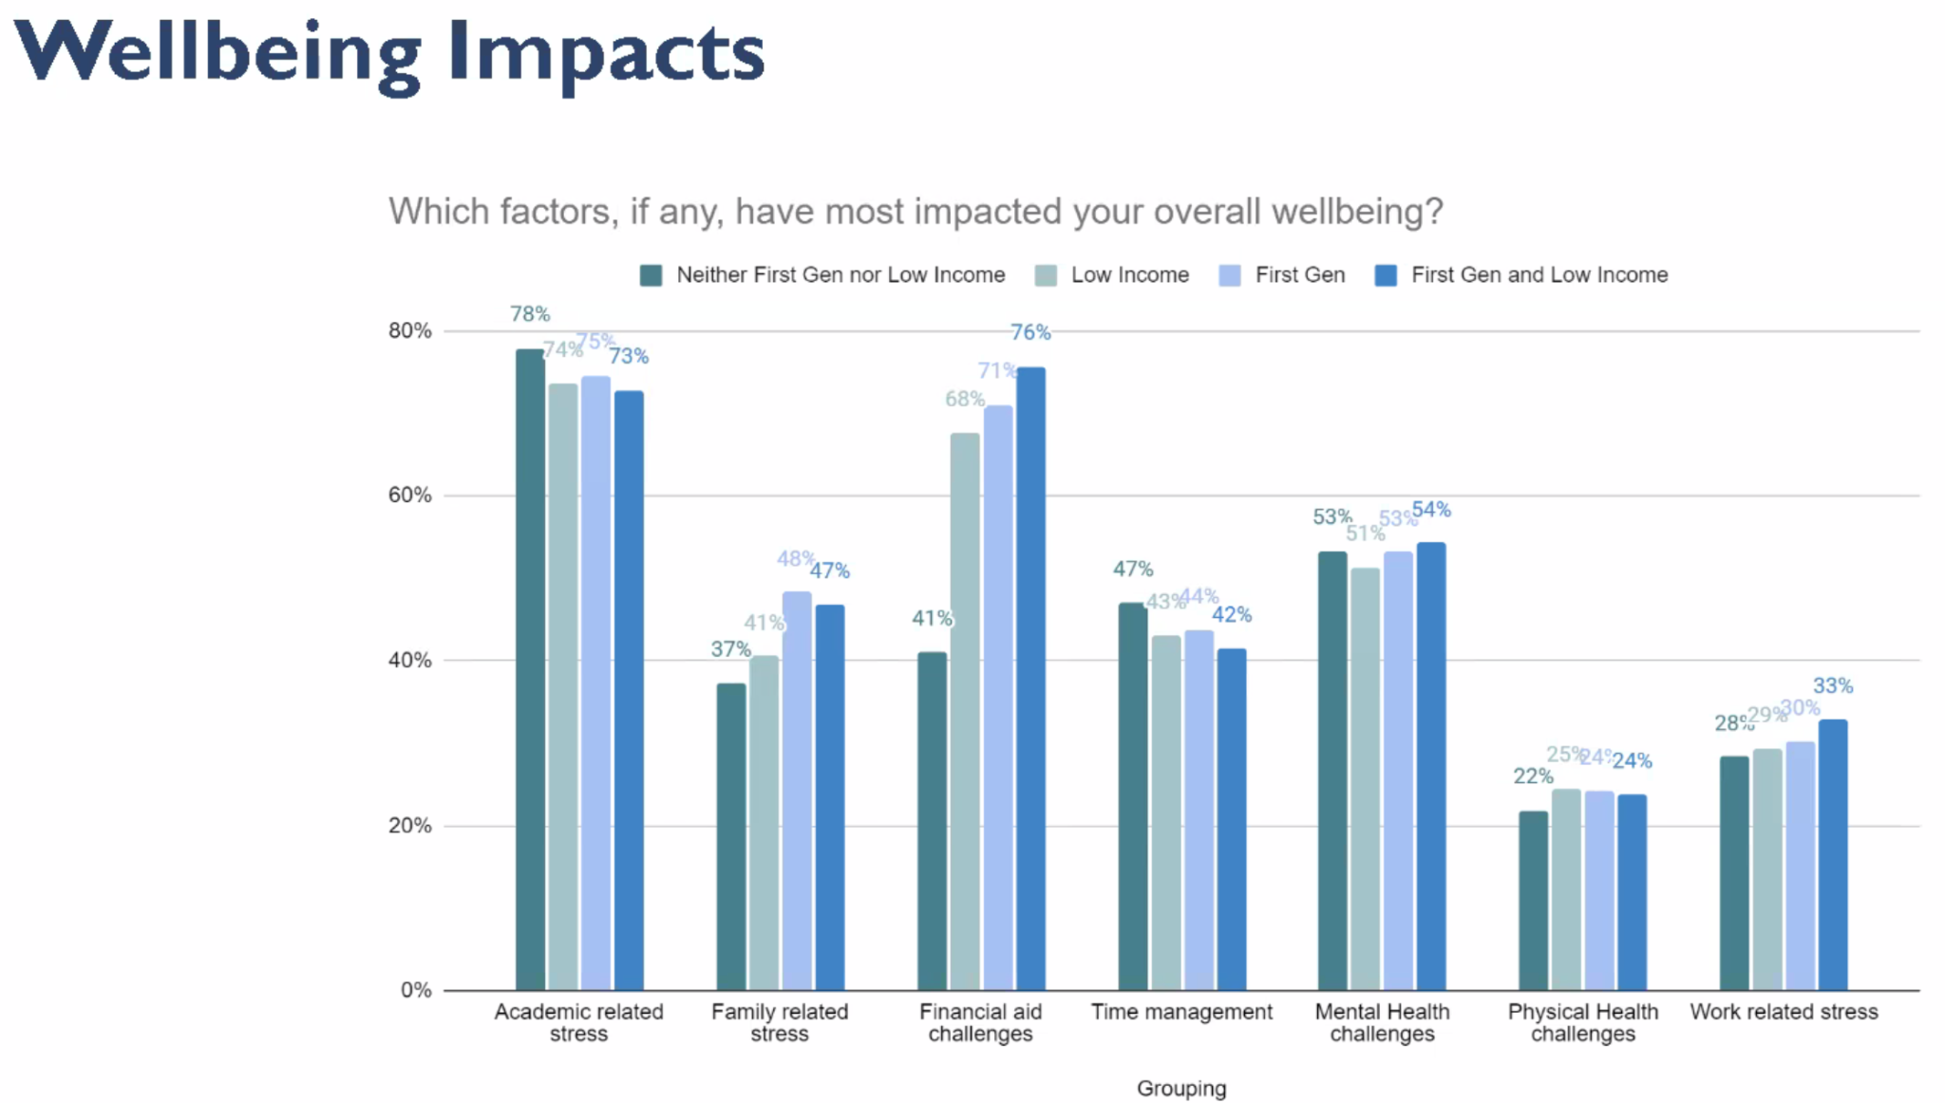
    - 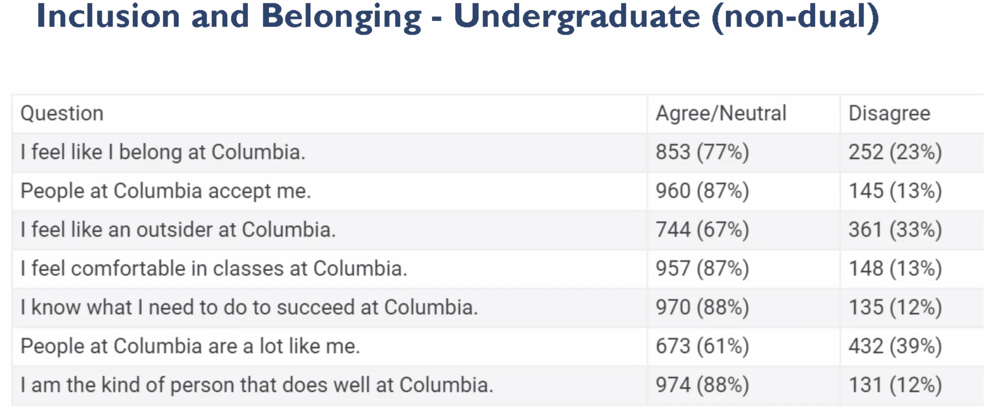
    - 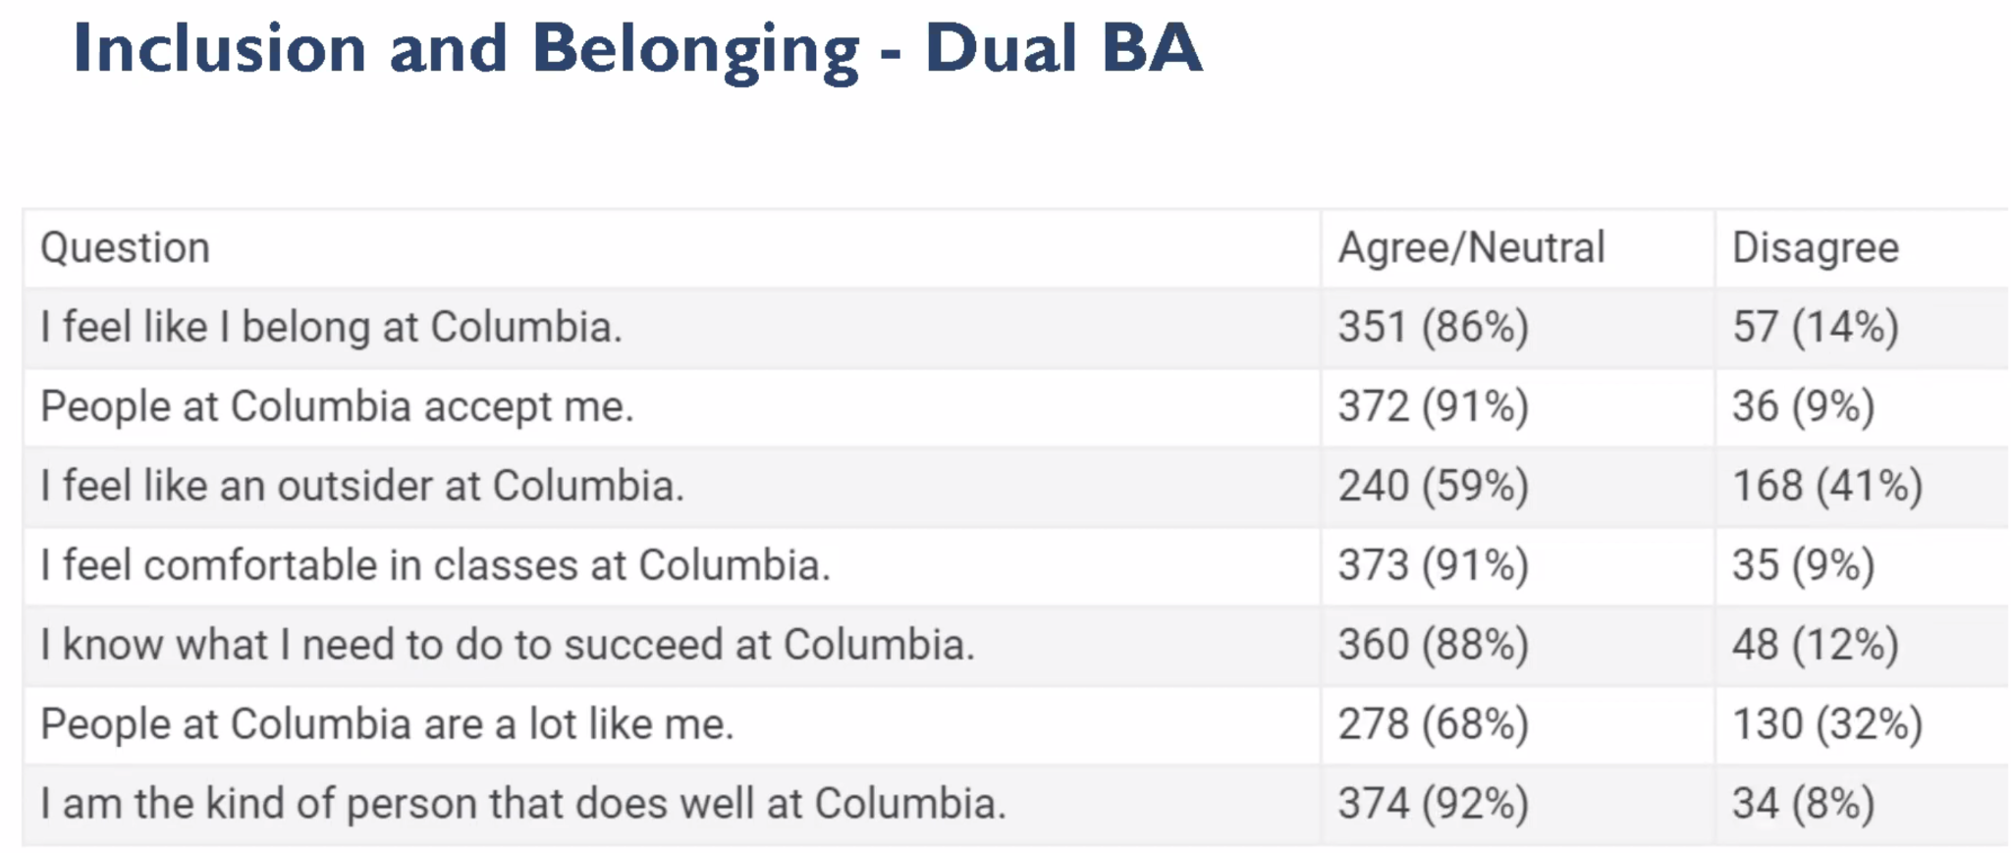
    - 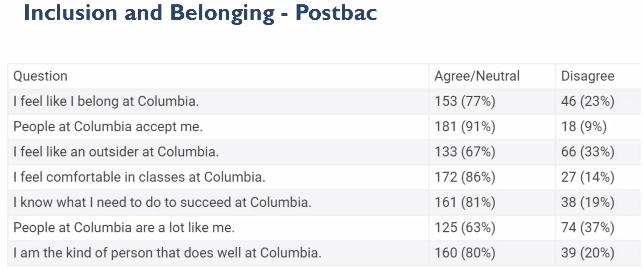
    - 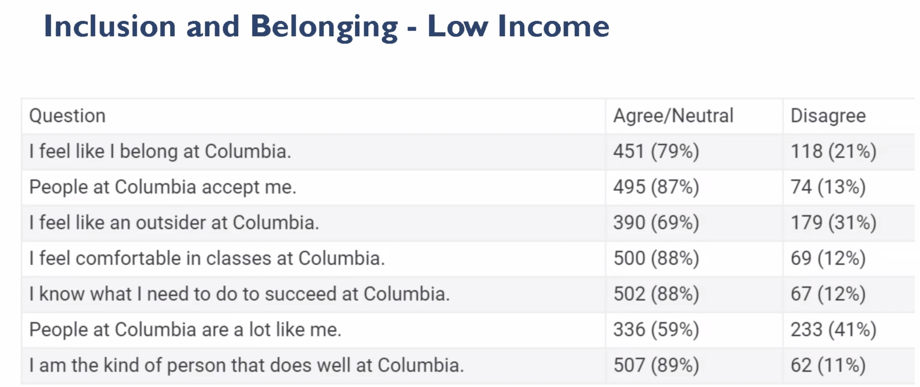
    - 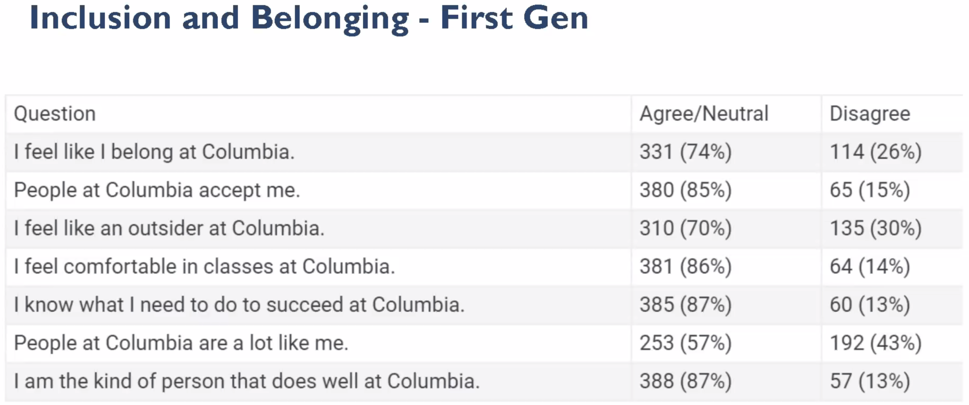
    - 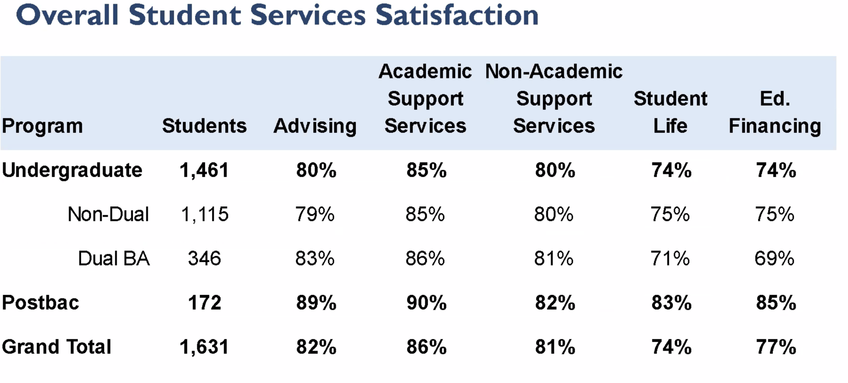
    - 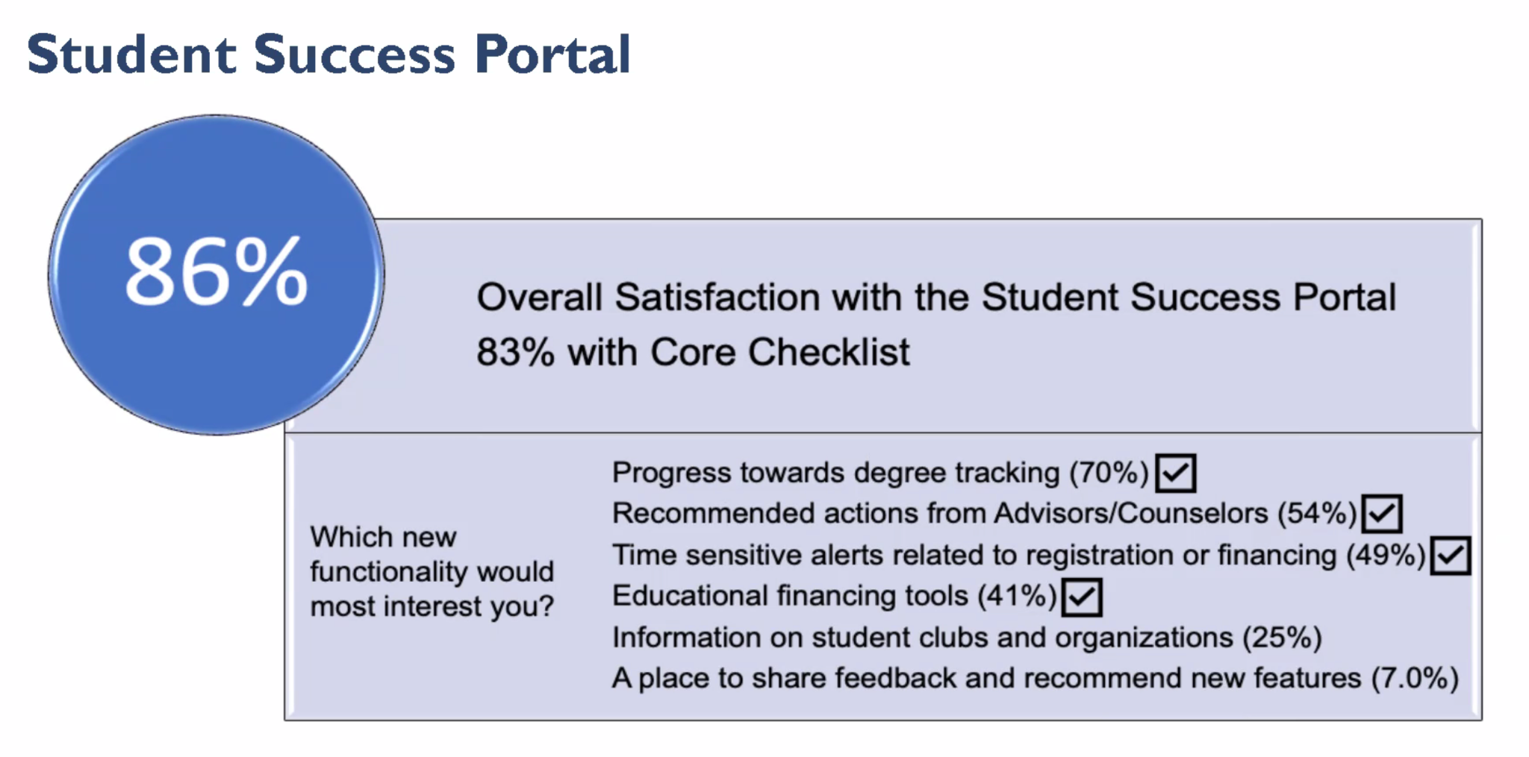
    - 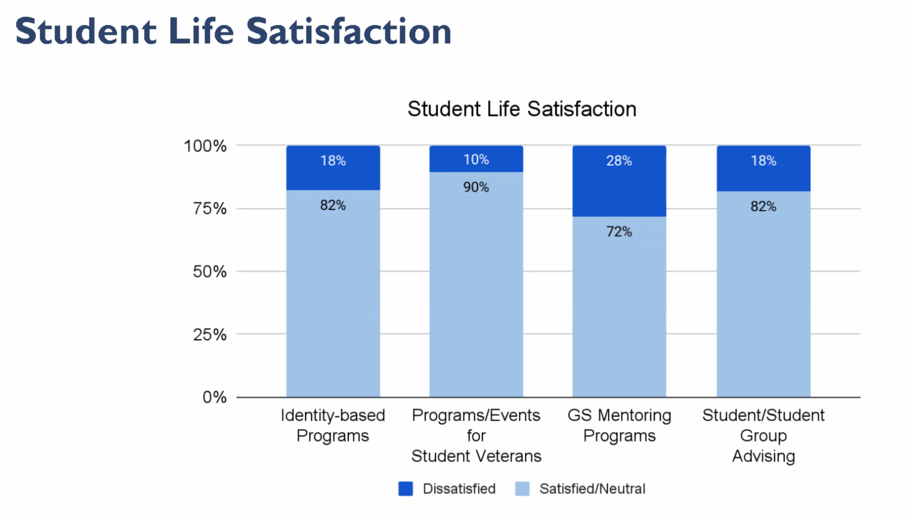
    - 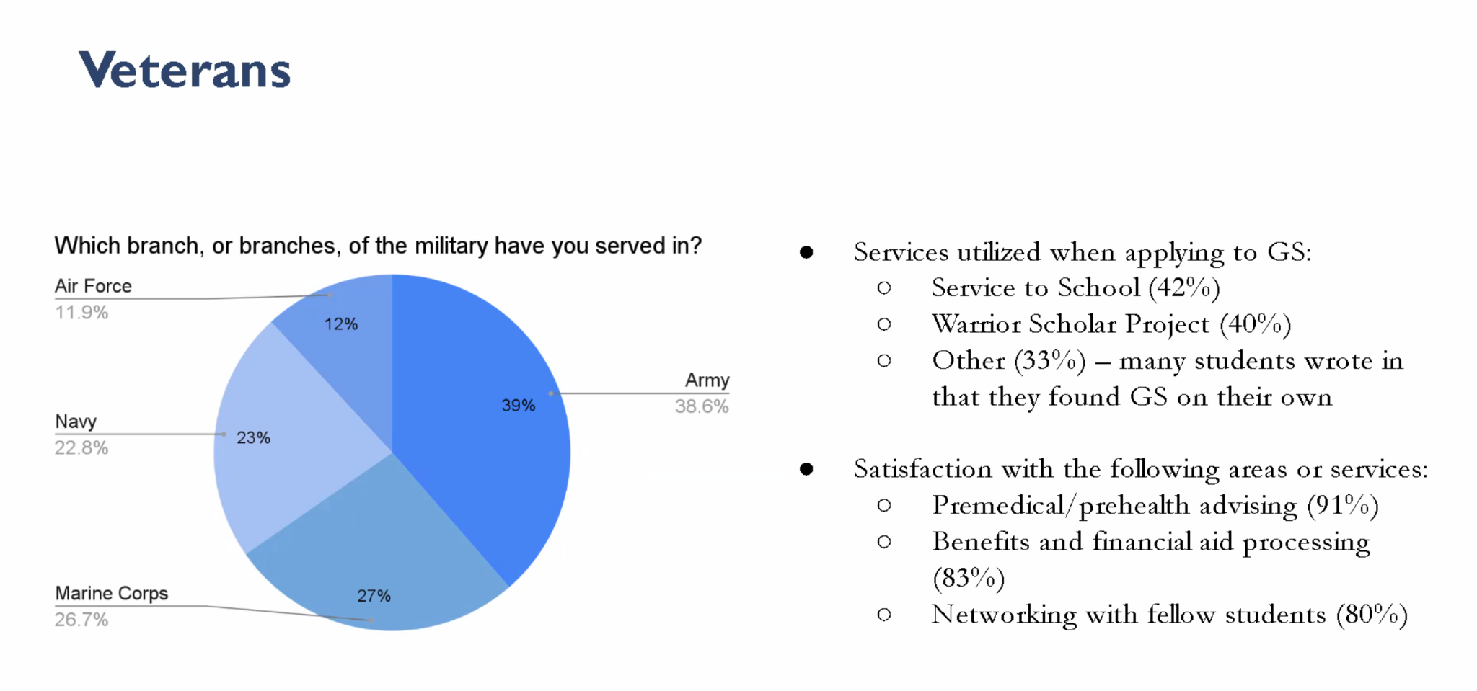
    - 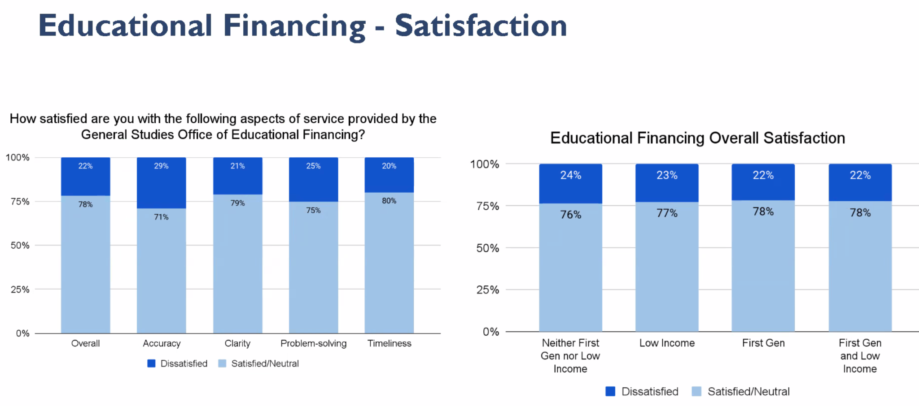
    - 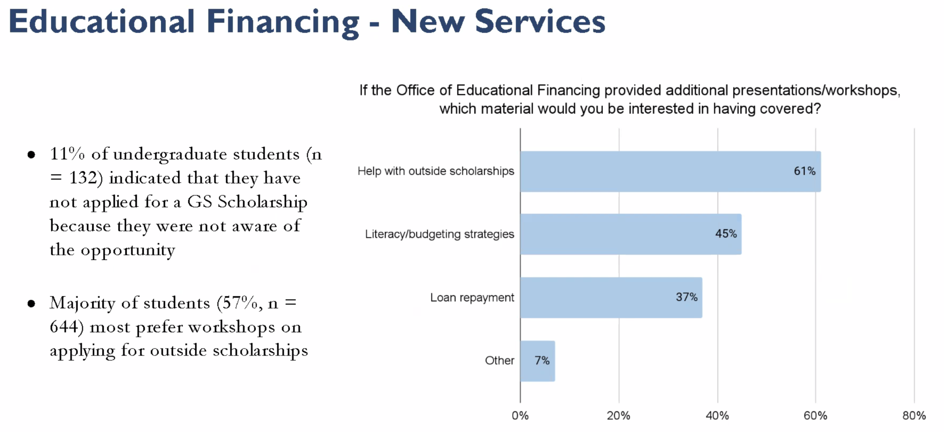
    - 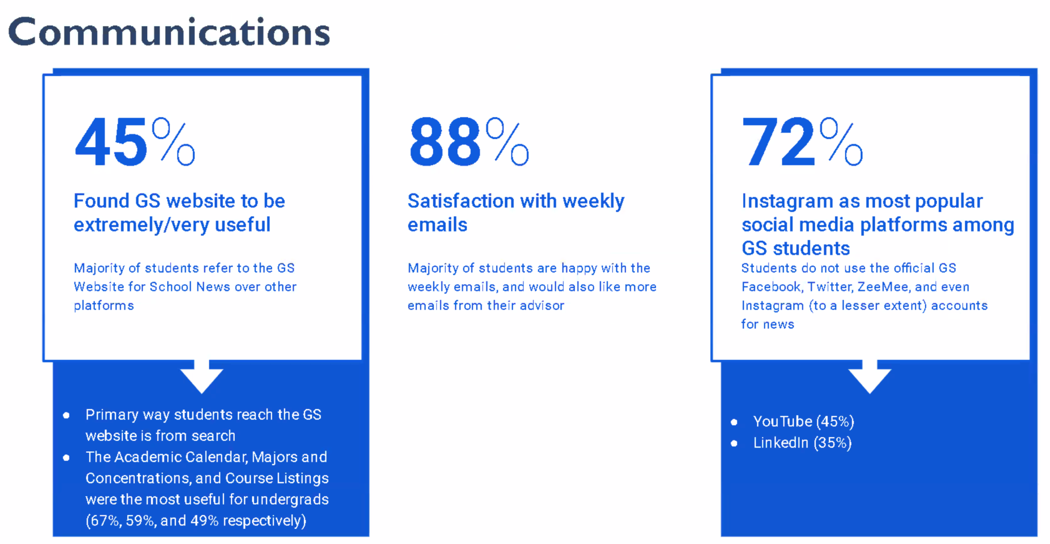
    - 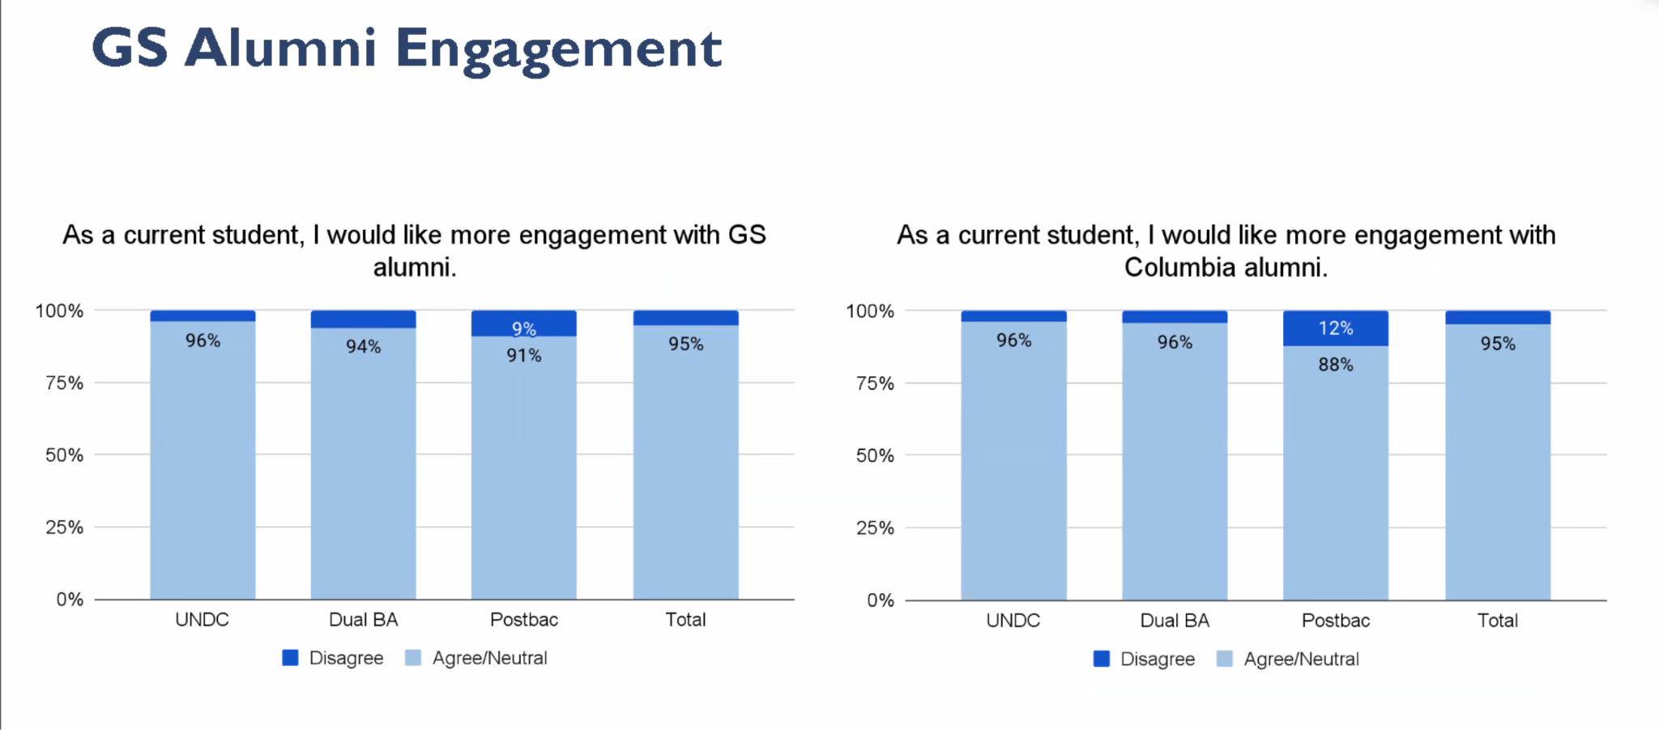
    - 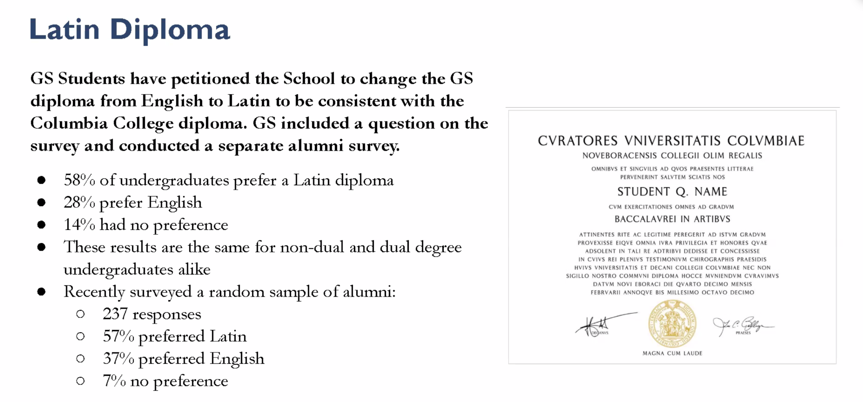
  - Questions:
    - Question for Nasser about improving the connection between Milvets and GSSC
      - Open to new ideas for communications
    - How can we access the data and the next steps to approach board of trustees?
      - We are advancing steps
    - How will the survey be used to advocate for equitable treatment for students or faculty? - clarification: a big part of the issues GS students face is culture of hard work, gets in the way of well beings, lessens output. GS students from survey are facing a different challenge. How can we give the data to professors?
      - We have shared the findings with President Shafik, and will be sharing the findings with the professors.
    - How involved will Shafik be in sharing this data with the board etc? How involved is Shafik in looking at this data?
      - She is very involved and interested in GS students
    - Will this survey be run with more regularity? Yearly or bi-yearly?
      - We are committed to doing this every other year (last time (before 2023) was 2018). We are already looking to get it out next Spring
    - The data associated w the current usage of the food pantry isn’t readily available, not publicly available - is that something that is being discussed in the new administrative body that is running the food pantry?
      - We will look into that
    - If someone who graduated a while ago loses/damages their diploma requests a new one, will their new diploma be in English or in Latin?
      - I believe it will be in English (due to signatures & technicality etc)
    - Will these slides be available to students at GS?
      - We are going to discuss how to make the data/results available
    - Would it be possible for us to stay informed of the progress with what is being done for all of the issues that are coming to light?
      - This is the highest priority. I would be happy to be invited back at any point to give updates. Highest priorities are for highest needs students.
    - The veterans do not have their own safe space on campus. What is being done about this? We are the only protected class that does not have a safe space.
      - (answered by Dean Rogers) There is a veteran space in Kent Hall - unfortunately it is closed for the renovations at the time. We have programming that takes place there as well. It is not a “lounge” per say but it is a space for veterans by veterans. We hear the feedback on wanting a lounge.
  - LM2892@columbia.edu - feel free to email Dean Lisa Rosen-Metsch! She will try to get back as soon as she can

REPORTS
  - President - evan
    - General Updates
      - just had town hall - informative
      - meeting with dean marvin earlier today went well, talked about a lot of things including:
        - core reforms, registration, waitlist, syllabi, research, etc, etc.
        - marvin seems excited to do some productive work and shares a lot of interests with us
  - Policy
    - election committee update:
      - started to put together a team, they’re here tonight
  - Finance
  - Communications
  - Campus Life
    - keep sharing LENS survey!!
    - guys seriously it’s 10 free dollars who isn’t doing that

- NEW BUSINESS
- Vote for Approval of: PJ Sonnen, Cary Htan, and Cody LeGross- Isabel
- Exterior from council so that it’s unbiased
- Two for co-chair position and one for communications
- Two more positions will be recruiting this weekend–everyone please share!!
- Hopefully by next week we will have a complete task force
- Not for council itself everyone will come and present and tae questions, discussion will happen in exec session
1st-PJ Sonnen- Co-Chair
  - 3rd year studying polisci
  - Election chair with community college, served full time in the army, done student council elections
  - Facilitated elections for US military personnel deployed outside their home state
  - Goal: to ensure a fair and democratic process, increase voter turnout/student participation, full transparency between the ETF and the SE, admin, and GSSC, keep everyone well informed and up to date
  - Question: Are you aware that this means that you cannot be on council next year–yes
  - Question: What’s your workload this semester? -Not bad - have the time
  - Question: How did you find out about this position? Brian Johnson, our veteran students rep.
2nd-Cary Htan- Co-Chair
- Sophomore at GS from NY, major in Compsci minor in biology
- Leadership experience, community service club in LA, familiar with this kind of thing
- Wants the ETF to be fair and transparent
- Question: Do you have time to do this position–Yes
- Question: You are aware you cannot be on council next year-Yes
3rd-Cody LeGross- Comms
- First year here at Columbia
- Professional career before CU, lots of communication experience with vendors and staff
- Question: You are aware you cannot be on council next year-Yes

STANDING BUSINESS
  - Dual BA [& Joint Program] Coffee Chat
    - Change to Dual BA & Joint Program
    - Motioning for additional $65 - add kosher pastries
    - Passes unanimously

COMMUNICATIONS FROM THE FLOOR
This time is reserved for any General Studies Student Council Members to make announcements on items not on the agenda. A time limit of three (3) minutes per speaker and (25) twenty-five minutes total shall be observed. NO action will be taken and the total time limit for this item shall not be extended.

PUBLIC COMMENT
This segment of the meeting is reserved for all non-Council members desiring to address the General Studies Student Council on any matter of concern, A time limit of three (3) minutes per speaker and ten (10) minutes per topic shall be observed. The law does not permit any action to be taken, nor extended discussion of any items not on the agenda. The General Studies Student Council may briefly respond to statements made or questions posed. (Brown Act §54954.3)

EXECUTIVE SESSION
This closed session is reserved for any General Studies Student Council Members to discuss and possibly take action on voting in the nominees for various, posted, council vacancies. The public, and the nominees, will be asked to step out of the room while the council conducts this business.

ADJOURNMENT

